**Implementing a Feedforward Neural Network in Python using Keras and TensorFlow for Wine Quality Prediction**

**Introduction**

Wine quality prediction is a crucial task in the wine industry, helping to maintain and improve production quality. Various chemical properties of wine, such as acidity, alcohol content, and sugar levels, influence the final quality of wine. By leveraging machine learning techniques like **Feedforward Neural Networks (FNNs)**, we can build models to predict the quality of wine based on these characteristics.

**Theory**

Feedforward Neural Networks are a type of artificial neural network where the flow of information is strictly in one direction: from input nodes through hidden layers to output nodes. In this architecture:

1. Input Layer: The input layer accepts the dataset’s features (e.g., acidity, alcohol).
2. Hidden Layers: These layers consist of neurons that process information using activation functions like ReLU or Sigmoid.
3. Output Layer: The output layer produces the final prediction (e.g., the quality score of wine).

**How FNNs Work**

1. Forward Propagation:
   * Input data is fed into the network, where each neuron computes a weighted sum of its inputs, applies an activation function, and passes the result to the next layer.
   * The last layer generates predictions.
2. Error Calculation:
   * The difference between the actual output (the true wine quality score) and the predicted output is calculated using a loss function (e.g., Mean Squared Error for regression or Categorical Cross-Entropy for classification).
3. Backpropagation and Weight Update:
   * The error is backpropagated through the network, and optimization algorithms like Gradient Descent are used to update the weights to minimize the error.
4. Training:
   * The model is trained over multiple epochs where the network continuously adjusts its weights to reduce the prediction error and improve accuracy.

**Steps to Implement Feedforward Neural Network for Wine Quality Prediction**

**Step 1: Install Necessary Libraries**

Ensure you have TensorFlow and Keras installed. These libraries provide the necessary tools to build and train neural networks. Installation can be done via pip if they are not already installed.

**Step 2: Import Required Libraries**

Start by importing TensorFlow and Keras, which are essential for building and training the neural network. Additionally, import libraries for data manipulation (such as pandas for handling dataframes) and preprocessing (such as scikit-learn for scaling data).

**Step 3: Prepare the Data**

Download the wine quality dataset, which typically includes features like acidity, pH, alcohol content, and other chemical properties of wine. Load the dataset into a pandas dataframe and inspect the data to understand its structure and the distribution of different quality ratings.

**Step 4: Data Preprocessing**

Preprocess the data by handling any missing values, if present. Split the dataset into features (input variables) and labels (target variable). Standardize or normalize the feature values to ensure they have a similar scale, which helps in improving the performance and convergence of the neural network. Split the data into training and testing sets to evaluate the model’s performance.

**Step 5: Build the Model**

Construct a feedforward neural network using Keras' Sequential API. Define the input layer to match the number of features in the dataset. Add one or more hidden layers with a specified number of neurons and activation functions (e.g., ReLU). The output layer should have a single neuron with an appropriate activation function (e.g., sigmoid for binary classification or linear for regression) to predict the wine quality.

**Step 6: Compile the Model**

Compile the neural network by specifying the optimizer (such as Adam or SGD), loss function (such as mean squared error for regression), and evaluation metrics (such as mean absolute error). This step configures the model for training.

**Step 7: Train the Model**

Train the neural network using the training data. Specify the number of epochs (iterations over the entire dataset) and the batch size (number of samples per gradient update). Monitor the training process by tracking the loss and evaluation metrics on the training and validation data.

**Step 8: Evaluate the Model**

After training, evaluate the model’s performance on the testing set. Check metrics like mean squared error, mean absolute error, or accuracy, depending on whether the problem is regression or classification.

**Step 9: Make Predictions**

Use the trained model to make predictions on new, unseen data. Compare the predicted wine quality with actual values to assess the model's generalization ability.

**Diagram of a Feedforward Neural Network**

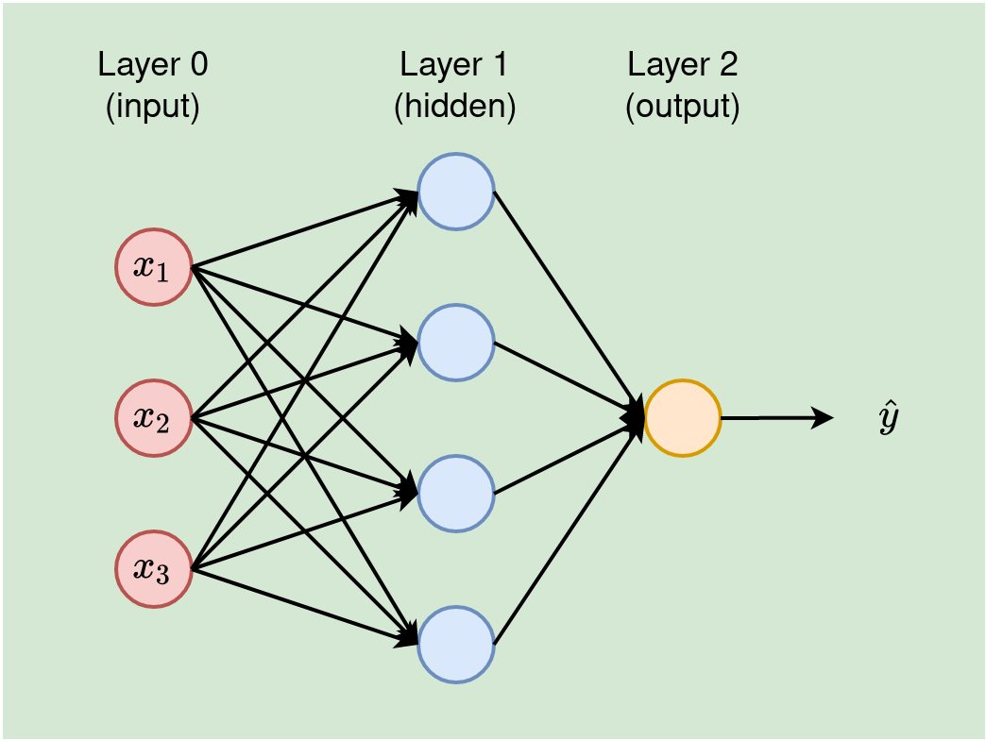

In this network, data flows in one direction from the input layer through the hidden layers, and finally, the output is produced.

**Wine Quality Neural network:**

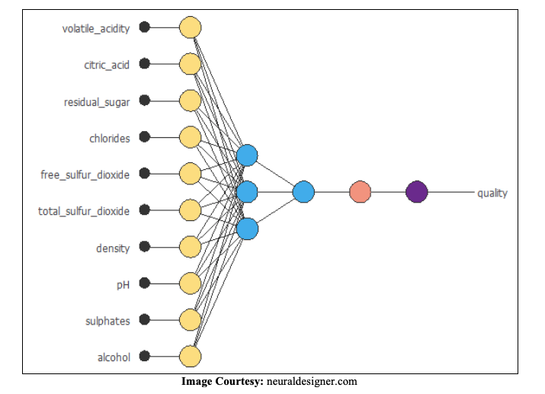

**Advantages of Feedforward Neural Networks**

1. **Simple Architecture**: FNNs are straightforward to understand and implement, making them ideal for beginners.
2. **Universal Approximation**: Given enough neurons and layers, FNNs can approximate any continuous function, making them powerful tools for complex tasks.
3. **No Cycles**: The absence of cycles in FNNs makes them computationally simpler compared to recurrent neural networks (RNNs), where data flows in loops.

**Disadvantages of Feedforward Neural Networks**

1. **Prone to Overfitting**: Without careful regularization (e.g., dropout, L2 regularization), FNNs can overfit the training data, leading to poor generalization.
2. **Data Requirements**: FNNs typically require large amounts of data to perform well, as they need to learn from numerous examples to capture patterns.
3. **Long Training Times**: Training deep FNNs can be computationally expensive, especially with large datasets or a high number of layers.

**Conclusion**

Feedforward Neural Networks are powerful tools for predicting wine quality based on chemical properties. By leveraging the simplicity and flexibility of FNNs, we can build robust models that approximate the relationships between input features and output labels. However, care must be taken to prevent overfitting and ensure that the model generalizes well to unseen data.